**IONAD NAOMH PÁDRAIG**

**PLEAN STRAITÉISEACH**

**2024 – 2028**

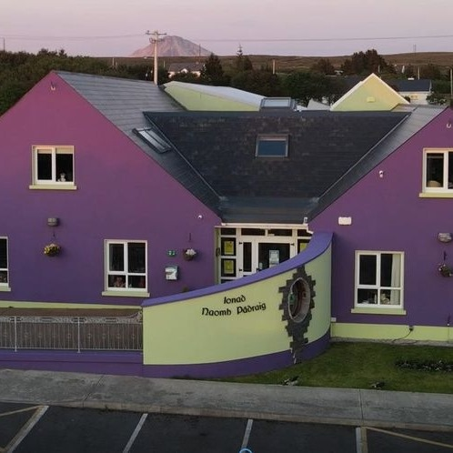

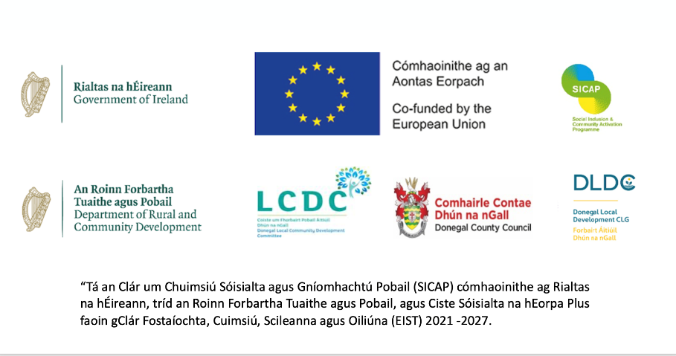

**Executive Summary**This plan sets out our needs and goals for the next phase of our growth. The hallmarks of our next phase will be responsiveness, care, stability, continuity and measured growth. We plan to reorganise some elements of how we work so we can try different things to meet our community’s evolving needs. We also plan to maintain and develop our existing services in response to local needs, so that people in our community have access to as wide as possible a range of services despite the social, economic and infrastructural challenges that our rural community faces. Our ability to maintain services depends on the availability of appropriate staff. Our community and area remain severely constrained by economic and social disadvantage, and we need additional staff to continue our work.

To continue to meet our community’s needs, and to deliver services and supports in a safe and effective manner, we have identified a number of pressing needs for our organisation including:

* Maintaining existing services to meet local needs
* Ensuring that Ionad Naomh Pádraig can provide outreach services for isolated, marginalised and vulnerable people in our community
* Securing funding to appoint 4 additional Full Time Equivalent staff
* Developing additional space
* Restructuring of current building to accommodate changing needs
* Securing stable funding to meet increasing running costs
* Ensuring that Ionad Naomh Pádraig has the resources (funding, people and other supports) for training, development and well-being of staff members
* Sourcing funding for an Energy, Environmental and Sustainability Audit – to help Ionad Naomh Pádraig become more self-sufficient on our journey towards greater sustainability and reducing our environmental impact

**IONAD NAOMH PÁDRAIG**We are a community-based organisation based in Dobhar in the northwest Donegal Gaeltacht. Our work has been the primary engine for rejuvenation and the building of local community capacity since 1996. This work has continued and grown further following our incorporation in October 2003 (Company Registration Number 377174). We have charitable status from the Revenue Charities Unit (reference number 16269) and are registered with the Charities Regulatory Authority (number 20058227).

**Our Purpose and Mission**Our founding purpose is to promote positive social change and community development and we exist to “*establish, promote, fundraise, operate, manage and develop a Community Centre, its grounds and all its resources as a community managed facility dedicated to the direct provision of community support, development, enterprise and education services for children, young people, parents and families in the area*.”

This purpose is reflected in our Mission Statement: “*Our mission is to be an excellent provider of community support, development, enterprise and education services that are relevant to the needs of children, young people, parents and families in our area.*” We do this by offering local social, economic and community services that tackle disadvantage by filling gaps in service provision and by responding to local needs.

Our aspiration is to inspire people from all walks of life to believe in themselves and to make a difference in their life and the lives of others.  
To make this happen we focus on:

* Putting people, and their needs, at the centre of everything we do
* Maintaining excellence in standards and quality of our services
* Ensuring that we have the staff, facilities, equipment and training that we need
* Maintaining and developing our capacity and our skills so we remain effective in our work
* Developing resilience in our organisation
* Providing a centre where local people can have access to services, facilities and advice
* Researching and identifying needs within our community
* Encouraging more people to become involved in community development, particularly people and groups that are socially excluded
* Supporting new and existing groups that are for the benefit of the community

Our objectives and work resonate with objectives set out in the Government’s *Action Plan for Rural Development* (https://www.gov.ie/en/policy/ac9ee6-action-plan-for-rural-development/) which are to:

* 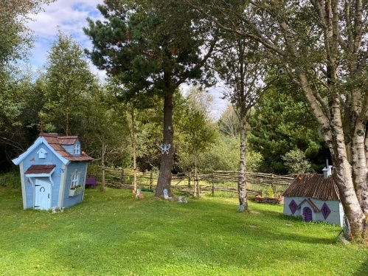Support sustainable and vibrant rural communities
* Support enterprise, career opportunities and quality employment
* Maximise our rural tourism and recreation potential
* Foster culture and creativity in rural communities
* Improve rural infrastructure and connectivity
* Develop and achieve a healthy community by jointly addressing economic, environmental, and social issues

Government strategy for Rural Ireland recognises that our rural communities need to be places where people can live, work and raise their families in a high-quality environment. Government strategy also aims to support the enterprise and jobs potential of rural Ireland and sets out to greatly improve access to arts and cultural events and facilities for residents of rural areas. Importantly for our community, Government strategy for supporting Rural Ireland also identifies the need to promote the Irish language as a key cultural resource. For us the Irish language is our daily language, and it is much more than a cultural resource.

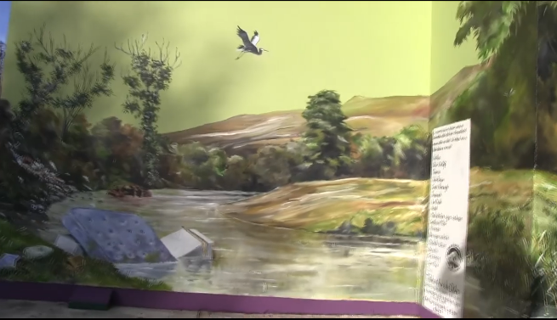

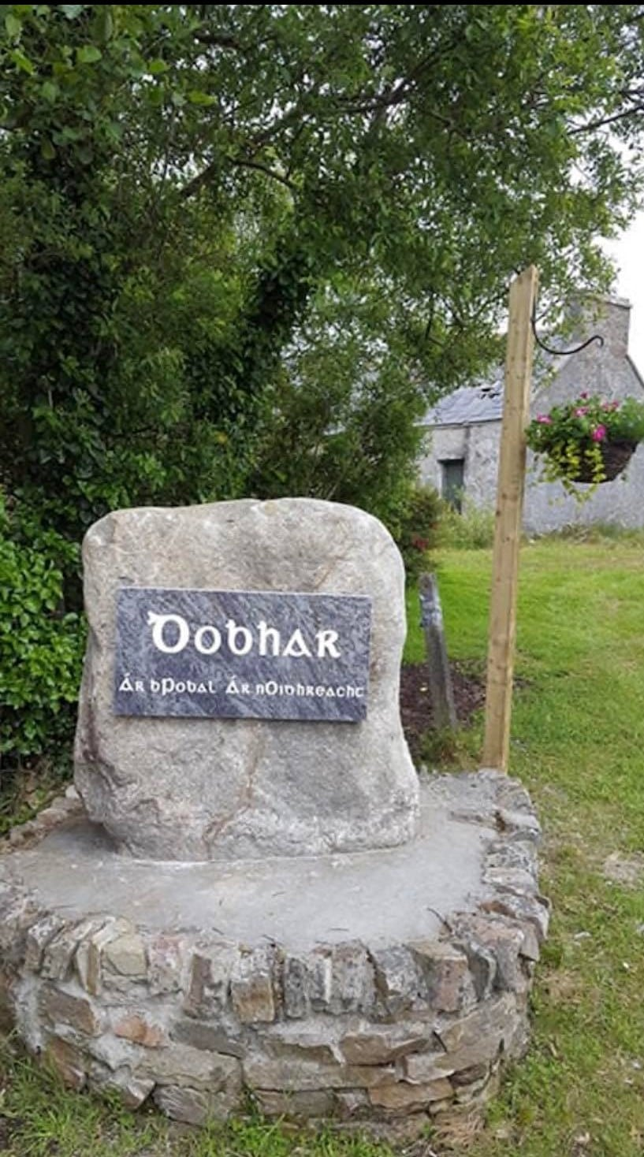**Our ambitions**We put people first and our strategic and operational focus will always be on the people who need the services that we provide.

Our high-level ambitionsare to:

1. Maintain and develop the range and quality of our services
2. Maintain and develop our building and facilities
3. Ensure we have the appropriate number and mix of staff
4. Stabilise our income and identify new income opportunities
5. Maintain our skills, qualifications and capabilities

To realise these ambitions we will:

1. Ensure that people in our community are able to avail of social, community and other services to which they are entitled but to which access can be difficult in rural areas – we aim to maintain and increase our services in response to local needs.
2. Ensure that we are able to meet the needs of the most vulnerable in our community, the new communities and in particular Donegal Cancer Flights and Services which is an essential service for people who are affected by cancer and their families.
3. Make the best use of all of our resources and facilities, as funding allows, so that we continue our work as an effective and empathetic community focused service organisation; this means changing how we do things and how we use our facilities to attract more varied uses thereby providing more options for the community and also creating opportunities to generate revenue.
4. Secure increased funding to allow us to appoint 4 x additional Full Time Equivalent staff numbers to ensure we can maintain existing services in the face of growing demands within the community.
5. Increase FTE staff numbers to allow us to introduce additional services to meet the changing needs, profile and demographics in our community and catchment area, to support both existing services and establish new business opportunities; this will include recruiting

* 1 x Full Time Equivalent to manage and develop Donegal Cancer Flights & Services
* 1 x Full Time Equivalent staff in Childcare,
* 1 x Full Time Equivalent staff in catering / cooking to service the Coffee Shop.
* 1 x Full Time Equivalent staff – coffee shop supervisor / waiter

1. Increase the usage of our building and facilities, and develop new income streams from rental of space and facilities.
2. Develop a costed plan to secure additional space, ideally within or adjacent to our current site, to enable us to meet the increasing demands on our services.

**Our values**Ionad Naomh Pádraig is committed to ensuring that our community is able to avail of the services and opportunities for wellbeing and personal development to which all citizens are entitled. Our approach is rooted in the principles and values of community development, and we place particular importance on the Irish language and culture which are defining characteristics of our community’s identity.  
Our work is guided by the following values:

* Respect: we respect the needs and aspirations of each person who we engage with
* Dignity: we value everyone’s dignity and we aim to reflect this in everything we do
* Openness: our services are open to all those who need them, and we are open to people’s ideas and suggestions about how we can do better
* Education: we value the power of education to enable people to make better choices in their lives, and to create opportunities for their personal development and growth as active citizens and as members of our community
* Quality: we aim to provide excellent services and we work to achieve high quality in everything we do

**The people we serve**From day one we have worked and planned to make sure that there has been a comprehensive framework of activities that presents the people of our community with every opportunity to participate more fully in community life, improve wellbeing and thus foster a deeper sense of identity.

Our main user groups include Early Years, primary and secondary school children, the elderly, people with disabilities and learning difficulties, people affected by cancer and lifelong illnesses, new communities, women’s groups, men’s groups, bereavement group, parent and toddler group, and voluntary groups involved in environmental activities. Our centre has good physical infrastructure that enables us to offer meeting /conference facilities for groups and businesses including an auditorium that is fully equipped with surround sound, projector and screen, IT / Hot Desk Suite, Recording Studio / Music Room, Children & Youth Education and Recreation room / Sensory room, Heritage / Coffee shop, classrooms and meeting rooms. Our outdoor facilities include Community Garden, All-weather Football pitch, outdoor play area, walkways and a sculpture located on the Gweedore Business Park in loving memory of our dear young people who have died in the vibrancy of their youth and who live forever in our memories and hearts.

**The services we offer**We are in the business of providing social, human and community services in a rural Gaeltacht area that continues to struggle with social, economic and other challenges. Through our work we aim to promote wellbeing for all in our community, to combat social and other forms of exclusion, and to encourage people to feel equipped to play their part as active citizens in developing and nurturing their community.  
We deliver a broad range of services through Irish, the first language of our community, and these services are supported by public bodies and agencies whose priorities and objectives are in Irish-language planning and development, health and social care, education, enterprise and community development. Our services are targeted at children, young people, parents, family groups, seniors and other groups whose needs we can identify and help to address. Ionad Naomh Pádraig offers a range of services designed to meet people’s needs at different life stages, from infancy through to senior years. The Centre is widely used by both young and old.  
Ionad Naomh Pádraig plays a central role in fundraising, coordinating and managing a particularly important service for cancer patients and their carers to enable them avail of air transport to Dublin and ground transport to Galway, Roscommon, Sligo, Letterkenny and Derry hospitals. This removes some of the difficulties faced by these vulnerable people at times of great need and stress, and the service is constantly in demand and needs constant management and regular fundraising. The formal arrangements are that Donegal Cancer Flights & Services is a sub-group of Ionad Naomh Pádraig and forms a major part of our daily work. We are affiliated to The Irish Cancer Society and National Cancer Control Programme. The support services provided by Ionad Naomh Pádraig include:

* **Flights to Dublin -** we co-ordinate return flights to Dublin for cancer patients, family members, carers/companions. We also co-ordinate flights to Dublin for children with severe or life-limiting conditions and their families.
* **Community Car** - we have obtained the services of 10 volunteer drivers and provide ground transport to appointments in Galway, Roscommon, Sligo, Derry and Letterkenny hospitals.
* **Counselling -** we also provide free counselling to cancer clients and their families in conjunction with the Irish Cancer Society.
* **Information and Support -** we provide information, practical and financial support to cancer patients, their families and those who are struggling.
* **Pamper Days -** We also provide pamper days where clients are treated to a range of free therapies and treatments in the relaxed atmosphere of the Centre.
* **Volunteer Driver Service –** We work in conjunction with the Irish Cancer Society to provide transport from Dublin Airport to various hospitals throughout Dublin.
* **Care to Drive -** We work in conjunction with the Care to Drive service and also provide information on Travel to Care Allowance

The cancer support service is a good example of how Ionad Naomh Pádraig can respond in a strategic and effective way to help harness and coordinate resources that can be directed accurately towards the people who need them, and we can do so in a way that is friendly, respectful, humane and rooted in a strong sense of community values.

The cancer support services, are in addition to the range of services that Ionad Naomh Pádraig already provides and the following overview illustrates the range of our work and the diversity of target groups that we serve:

* Recreation facilities, education, IT skills, sports and fitness - aerobics, yoga, tai chi and circuits.
* Leisure, social and cultural activities which enhance positive outcomes within our community.
* Parent and Toddler Group, Parenting Programmes and Workshops, Learning Support, Early Years’ Service, Breakfast and Afterschool Service, Youth Club, Children’s Club, music, dance, gymnastics and exercise classes.
* Social Prescribing Link Workers providing a vital service throughout the Donegal Gaeltacht.
* Courses including Irish, French and Spanish language classes, arts and crafts, basket weaving, community garden, healthy eating and meditation.
* Concerts, celebratory events, (e.g. St. Bridget’s day, Easter, First Holy Communion Celebrations) and social evenings including Christmas Dinner for the elderly and the Emergency Services.
* Trips and social outings for the elderly and the youth.
* Outreach programmes in conjunction with the HSE / Sláintecare, such as COPD, Falls Clinic, Meitheal (Family Support), Antenatal.

**Our Community Centre and Facilities**Our community centre, Ionad Naomh Pádraig, is our most important physical asset as it enables us to provide a wide range of services and supports that we have identified through rigorous professional study and analysis over the years.

Our community centre building and facilities make it possible for our community, and particularly the most vulnerable individuals and groups in our community, to have access to the support services, experiences and opportunities for personal development and wellbeing that we can provide both on behalf of the State and at a more localised community-focused level.

Increasingly we see demand for more outdoor programmes of activities, and there has been a renewed locally interest in our environment and ecology. A practical outcome of this is the growth of interest in managing the public domain and working towards participation in Tidy Towns. We find that the Tidy Towns Committee has helped to stimulate and develop an element of shared responsibility and co-operation through the townland. Working together allows further development, pride and commitment from the wider community to ensure participation in the Tidy Towns Competition.

We see how our work makes an impact and difference. For example, the local community and the youth have taken more pride in the area and have worked hand in hand with our Tidy Towns Committee to ensure the upkeep of the general area. To underpin this progress, we continuously run a litter awareness campaign alongside the ongoing programme of maintenance for the upkeep of our walkways and community garden.

We aim to build on what our community garden offers, entice more participants to join, creating an annual growing plan. The organic produce from the garden will continue to be used in the kitchen to provide fresh vegetables and nutritious meals for our clients within the Centre and our meals on wheels service users. We will continue to build on growing a variety of traditional wildflowers to attract bees and other beneficial insects to the area.

**Context for this plan**.

Our community is in an area where many public and private sector services are lacking and where the risk of social isolation is high because of the geography of our area coupled with the lack of transport infrastructure. There are also demand deficits for services that our community needs but that are not being met by existing services.

Ionad Naomh Pádraig serves a wide catchment area which includes Gaoth Dobhair, the Rosses and Cloich Cheann Fhaola area that incorporates the HSE’s Bunbeg/Derrybeg primary care area which extends from Dún Lúiche to Machaire Rabhartaigh, and it includes Croithlí. This area sits within the northwest region of the Donegal Gaeltacht.

The community and voluntary approach is a process that activates, encourages, empowers and supports groups of people to join together in activities that promote their common interest, improve their communities and benefit all of society.

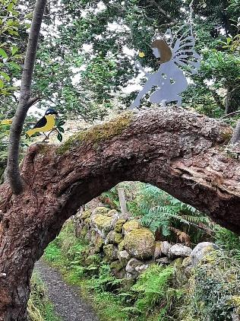Its key features include:

* Responsive, tailored and holistic approaches to identifying and meeting needs
* Flexibility, innovation, integration and collaboration in delivery
  + - * Ownership, involvement and empowerment of service beneficiaries and the wider community
* Contributing to building social capital and social cohesion
* Bringing additional sources of funding to support work that would not be available to the Stat

**Our Plans in response to this Context**We are an effective and successful social enterprise. We make it our business to understand the needs, aspirations and ambitions of our local community. We also make it our business to identify the barriers to full participation in community life and the barriers to active citizenship. Our services are designed, managed and delivered as thoughtful strategic responses to the realities of life in our community.

Our new plan identifies two main strategic directions for Ionad Naomh Pádraig, one is to maintain stability in the provision of existing services as a baseline of provision, and the other is to make strenuous efforts to secure resources to appoint additional staff.

Our work needs to continue and to develop, and Ionad Naomh Pádraig is operating at full capacity in terms of staff allocation – however this is not enough and it means that we are missing opportunities to improve our services and impact, and opportunities for generating new revenues from our building and facilities.

All of our facilities (as well as our staff) are under constant increasing pressure to meet the local demand within our community for services and support. We are able to respond in part to these increasing demands and new demands by adapting how we use our existing spaces but we require additional staff.

We have identified medium-term and long-term strategic actions that involve capital development to allow us to:

1. Increase our storage area with the addition of an outdoor toilet
2. Upgrade our outdoor facilities, specifically the play area, which will include outdoor sensory equipment in our community garden
3. Purchase additional land adjacent to Ionad Naomh Pádraig – Proposed Extension – additional classrooms, meeting rooms and office (long-term plan)

However, we are understaffed and while we struggle daily to deliver our existing services, there are opportunities that we simply cannot seize without the correct numbers of staff. We have identified specific requirements for additional staff to allow us to develop and enhance our services in a planned way that can also generate new and increased revenue for Ionad Naomh Pádraig to help us create sustainable models of social enterprise and employment within our community.

We urgently require additional 4 Full Time Equivalent staff to help us maintain and deliver quality services to our community, and to respond effectively to the increased demands for services, both existing and new. Demand for our services is such that it has allowed us to create sustainable jobs, plan for increased revenues, and create the capacity for further employment. We urgently need to increase our staff numbers so that we can employ four (4) Full Time Equivalent staff in the following roles: childcare worker, administrator specifically assigned to Donegal Cancer Flights and Services, additional full-time cook, and coffee shop supervisor / waiter.

|  |  |  |  |
| --- | --- | --- | --- |
| **Role** | **Quantity** | **Status** | **Responsibilities and duties** |
| **Administrator** | X 1 | FTE | • Daily management of Donegal Cancer Flights & Services  • Research the feasibility of outreach cancer screening services  • Establish a Cancer Support Group  • Seek funding to provide free travel  • The provision of cancer aftercare at local level  • Increase the number of pamper days  • Implementation of new schemes – Good Neighbour Scheme, Move More Campaign, Hospital in Town  • Additional counselling service to include addiction, bereavement etc |
| **Childcare Worker** | X 1 (Start up fund until financially viable) | FTE | • Increase the number of children in Early Years’ Service / Breakfast and Afterschool Service |
| **Cook** | X 1 (Start up fund until financially viable) | FTE | • Service the operational needs of the coffee shop / café in addition to existing duties in providing cooking for all current services |
| **Coffee shop supervisor/waiter** | X 1 (Start up fund until financially viable) | FTE | • Daily management of the operation of the coffee shop  • Essential to the smooth professional operation of the coffee shop, this is a fulltime role |

The childcare workers’ role will allow us to increase the number of children attending Early Years’ / Breakfast and Afterschool Service. The roles of cook (FT) and coffee shop supervisor (FT) will allow us to operate this facility up to 7 days a week, where appropriate, throughout the year. Additional staff will also alleviate serious pressure on the health and wellbeing of existing staff. Protecting the health and safety of our employees is a priority for us. There are specific operational issues that we need to address, including the provision of adequate staff cover at weekends and evenings, as well as the maintenance of training, skills and other funding, regulatory or statutory requirements – all of which have practical implications for organisations including additional costs and time commitments.

We envisage that the impact of the additional staff will be seen in increased or new revenue for Ionad Naomh Pádraig, something that will support us and our community in developing sustainable social enterprise activity within our community. The estimated total footfall through Ionad Naomh Pádraig in 2022 was approximately 57,000 people.

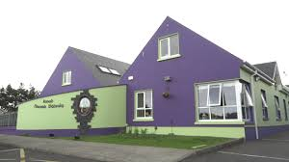

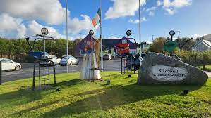

**Our Goals and Implementation Plan 2024 – 2028**

|  |  |  |  |
| --- | --- | --- | --- |
| **GOAL 1 - Maintain the quality of our services** | | | |
| **High-level goal** | **Actions** | **Resources required** | **Results** |
| **1.1 Achieve and maintain compliance with all relevant regulatory and statutory requirements** | • Annual audit of systems for maintaining compliance and standards • Quarterly review of compliance and standards • Provision of staff training and development | • Manager • Auditor • Directors • Pobal • ETB | • Stronger governance, increased efficiency and sustained delivery of high-quality services • Enhanced training and creation of an appropriate staffing structure to support the work we do within the community |
| **1.2 Ensure all staff are trained and supported to deliver services to the highest standards** | • Ensure that there is a staff development and training policy, with funding, to support staff in delivering services and doing their work | • ETB  • ICS • Pobal  • DLDC | • Delivery of enhanced services and community supports • More effective promotion of community development • More effective supports for vulnerable people in our community • Increased opportunities to encourage Volunteers and Scheme Workers to develop within the organisation • Greater resilience between staff, inspiring community development, strengthening skills and knowledge |
| **1.3 Ensure our facilities and equipment are up to standard and fit for purpose** | • Regime of safety inspections and reporting  • Identify funding opportunities for replacement/renewal as part of the organisation’s financial strategy • Staff training programmes, as required | • Annual Servicing (Fire safety, lighting, lift, hoist)  • Health & safety risk assessment • State funders such as Údarás na Gaeltachta, Leader, Donegal County Council | • Ensuring safety within the workplace for staff and clients. • Staff are adequately trained and equipped to manage and maintain facilities • Meeting all legal requirements for health & safety • Meeting all insurance obligations |
| **1.4 Ensure that our policies, practices and ways of working reflect our ethos and values in the interests of our community** | • Annual review of policies, operating procedures • Regular consultation among staff and clients • Include question(s) in annual survey questionnaire | • Committee • Manager | Ensuring that the facilities and services we offer are in line with the community’s needs |

|  |  |  |  |
| --- | --- | --- | --- |
| **GOAL 2 Secure Resources to maintain and increase services** | | | |
| **High-level goal** | **Actions** | **Resources required** | **Results** |
| **2.1 Set 2024- 2028 targets for generating income from current and planned services and facilities** | Produce income generation strategy that identifies targets for: • Income from services (public funding) • Income from current and planned new activities and services (earned income) | • Committee • Manager | • Clear means of tracking income achieved against targets to help ensure sustainability of centre • Improved ability to assess viability of current and new services |
| **2.2 Secure funding for 4 x FTE posts** | •Seek funding from POBAL, Foras na Gaeilge or other funding agencies  • Glór na nGael – Scéim Céimeanna | • Manager  • Staff | • Increased employment • Improved range, scope and reach of our services • Increased usage of our Centre and outdoors • More opportunities for personal and community development • Attainment of POBAL funding objectives and targets |

|  |  |  |  |
| --- | --- | --- | --- |
| **GOAL 3 Developing our building and facilities** | | | |
| **High-level goal** | **Actions** | **Resources required** | **Results** |
| **3.1 Sensory Room** | • Completion of project funded by Tusla  • To be officially opened in 2024 | • Manager  • Staff | • Upgrade of community facility  • Increased available space  • More opportunities for children with special needs to engage with the full range of facilities and services at Ionad Naomh Pádraig |
| **3.2 Secure funding for Phase 3 of our capital development plans –**  **Extension of Store and also incorporate an outdoor toilet** | • Secure support and funding in principle from at least one of the following: LEADER or An Roinn Turasóireachta, Cultúir, Ealaíon, Gaeltachta, Spóirt agus Meán  • Project management, design, build and commission Phase 3 2024 | • Manager  • Staff | • Clear picture of the capacity and resources needed to proceed with Phase 3 • Increased certainty and direction from 2024 onwards • Identification of feasible design, funding and operating models for Ionad Naomh Pádraig Phase 3 • Increased available space here in our main building through our Phase 3 capital development project • Local employment and economic benefits created before, during and after construction • Direct and indirect contribution to local economy |
| **3.3 Upgrade external space for outdoor activities** | • Upgrade a new outdoor play area and water dispenser adjacent to Ionad Naomh Pádraig by end 2025 | • Manager  • Staff | • Upgrade of community facility  • Direct and indirect contribution to local economy • Promotion of outdoor activities and health • More opportunities for people to engage with the full range of facilities and services at Ionad Naomh Pádraig • Capacity to generate income from the new facilities |
| **3.4 Develop an Alzheimer’s Cafe** | • Secure support and funding from HSE / Alzheimer’s Society | • Manager  • Staff | • Direct and indirect contribution to local economy • More opportunities for people to engage with the full range of facilities and services at Ionad Naomh Pádraig |
| **3.5 Develop an Irish writing course / scheme** | • Secure support and funding from ETB / Údarás na Gaeltachta | • Manager  • Staff | • Preserve the richness of the Irish Language  • More opportunities for people to engage with the full range of facilities and services at Ionad Naomh Pádraig  • Increase tourism in the community |
| **3.6 Purchase a Community Bus** | • Register on eTenders for suppliers  • Agree on supplier and purchase minibus  • Make returns to POBAL | • Manager  • Staff | • Increased connectivity in rural area • Promotion of health and wellbeing • More opportunities for people to engage with the full range of facilities and services at Ionad Naomh Pádraig • Direct and indirect contribution to local economy |

|  |  |  |  |
| --- | --- | --- | --- |
| **GOAL 4 Supporting the Wider Community** | | | |
| **High-level goal** | **Actions** | **Resources required** | **Results** |
| **4.1 Message in a Bottle** | • Secure support and funding from Muintir na Tíre | • Manager  • Staff | • Increased connectivity with the Elderly  • Safety at home |
| **4.2 Upgrading the 'Walk through the Generations' as well as providing seating and signage** | • Secure funding from the Irish Cancer Society  • Secure funding from Community Water Development Fund | • Manager  • Staff | • Meet the needs and demands of community  • Promotion of health and wellbeing • Promotion of outdoor activities |
| **4.3 Upgrade the Old Community Chapel** | • Secure funding from Town and Village Renewal Scheme  (application submitted) | • Manager  • Staff | • Upgrade of community facility  • More opportunities for people to engage with the full range of facilities and services in our community  • Increase the tourism infrastructure in the community • Direct and indirect contribution to local economy  • Increase connectivity in rural area  • Meet the needs and demands of the local and new communities here in the Gaeltacht |
| **4.6 Supporting Muintearas and Foróige in strengthening Ionad Óige Ghaoth Dobhair** | • Collaborative approach to achieve the overall goal of a purpose built youth centre  • Secure funding for youth workers | • Manager  • Staff | • Meet the needs and demands of the young people of the Gaeltacht  • Strengthen our efforts in terms of our goal, to develop a permanent, excellent, purpose-built Youth Centre of the highest quality in the heart of Gaoth Dobhair |
| **4.6 Develop a Housing Scheme with a language condition** | • Collaborative approach – working with stakeholders | • Manager  • Staff | • Addressing the housing crisis  • Promotion and sustainability of the Irish Language  • Addressing the needs of local families in the Gaeltacht |
| **4.7 Develop and preserve Bád Eddie as a tourist attraction here in Gaoth Dobhair** | • Collaborative approach – Ionad Naomh Pádraig/Bád Eddie Committee | • Manager  • Bád Eddie Committee  • Donegal County Council  • Údarás na Gaeltachta | • Feasibility and costings have been prepared for this proposal in collaboration with Donegal County Council, apply for Foreshore Licence  • Secure additional funding - Údarás na Gaeltachta has set aside €50,000 in principle for this project.  • Continue Fundraising Campaign  • Increase tourism in the community |

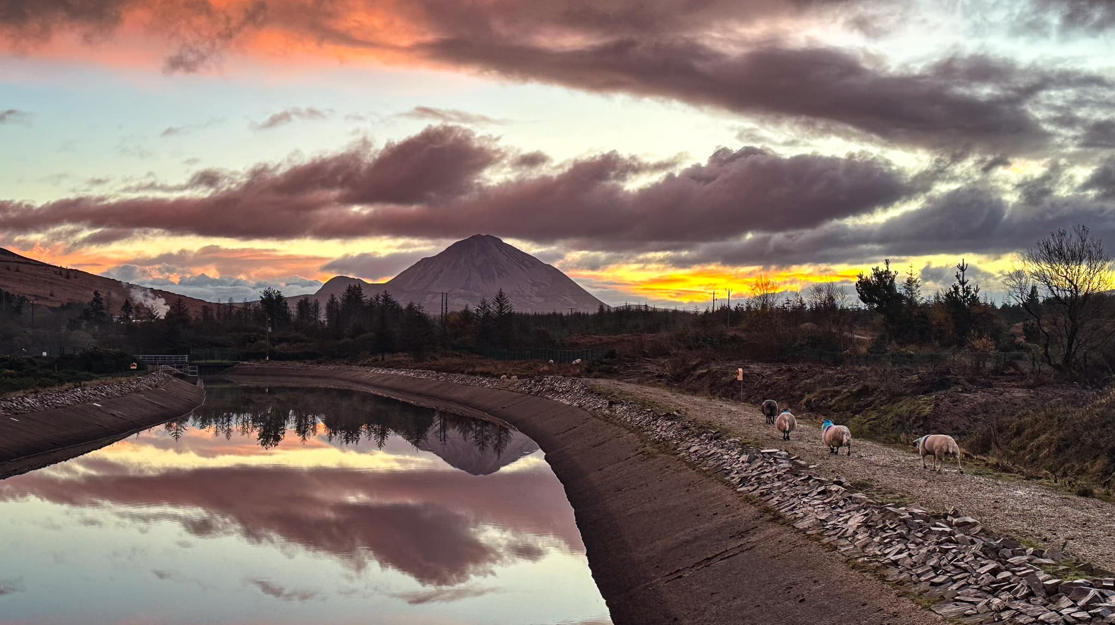

**Suaimhneas**

